 Mercy Medical Center Division of Nursing 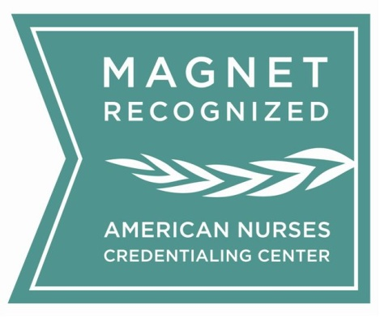
11th EBP/Research Symposium
“Power of Collaboration: Nurses Elevating Healthcare”
March 6, 2026 , 7:30am- 4:30 pm
Loyola University Maryland / McGuire Hall 4TH Floor
4501 N. Charles St. Baltimore, MD 21210
REGISTRATION FORM
Name: ____________________________________________________________________________________

Address: __________________________________________________________________________________

City: ____________________________________ State: ________ Zip: __________________

Home Phone: _________________________ Cell: _______________________ Work: __________________

Facility/Organization: _______________________ Unit: _________ Email: ____________________________
Continental Breakfast
& Lunch Provided
(must check preference)
Turkey & Havarti
Sandwich

Black Angus Hero (Beef)
Sandwich

Country Chicken Salad

Zucchini Sandwich
(Vegetarian)
Symposium Fee:
Mercy Employee / Primary Oral Speaker: No Fee
X
Before Feb. 15, 2026 After Feb. 15, 2026
Non- Mercy Employee: ____ $115 .00 ____ $125.00
EBP/Research Poster Abstract (Primary Only): ____ $100.00 ____ $110.00
Undergrad Student (Copy of Student ID Req.): ____ $ 60.00 ____ $ 65.00
X

Before Feb. 15, 2026: ___ Check ___ Credit Card
Please make checks payable to: Mercy Medical Center

After Feb. 15, 2026: CREDIT CARD ONLY

Submit registration form and payment via email or mail to Nicole Bezold (nbezold@mdmercy.com)
Mail: Nicole Bezold Credit Card
Mercy Medical Center Credit Card Type: ________________________ Expiration date: ___________
345 St. Paul Place Name on Card: ___________________________________________________
PCS Bunting 4 Floor Credit Card #: _______________________________ CVC/CVV Code: ________
Baltimore, MD, 21202 Signature: _______________________________________________________
*****
CALL FOR ABSTRACT: September 1, 2025 to Feb. 15, 2026 / Acceptance Letter: < Feb. 15, 2026
(Program Contact Information: Dina Krenzischek/ ekrenzis@mdmercy.com / 443-854-2124)
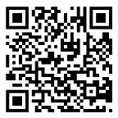
http://mdmercy.com/mercyresearch2026 (Contact Hours 8.0)

